**Multi-Disease Detection System with X-ray Images Using Deep Learning Techniques**

M. Suleman Basha1 A. Annapurna1 B. Suresh Kumar Reddy2

[suleman.ndl@gmail.com](mailto:suleman.ndl@gmail.com) [arikatlaannapurna@gmail.com](mailto:arikatlaannapurna@gmail.com) [basireddysuresh666@gmail.com](mailto:basireddysuresh666@gmail.com)

B. Dharani2  M. Nandeeswar2

[dharanireddy.b23@gmail.com](mailto:dharanireddy.b23@gmail.com) [nandeeswarmacherla@gmail.com](mailto:nandeeswarmacherla@gmail.com)

1Dept. of CSE (Data Science), Rajeev Gandhi Memorial College of Engineering & Technology, Nandyal

2Student, Dept. of CSE (Data Science), Rajeev Gandhi Memorial College of Engineering & Technology, Nandyal

**Abstract**

In the landscape of medical diagnostics, deep learning algorithms have emerged as formidable tools for disease detection and diagnosis. This study presents a pioneering Multi-Disease Detection System tailored for the analysis of X-ray images, leveraging advanced deep learning techniques. Focused on Alzheimer's disease, brain tumors, COVID-19 infection, and pneumonia, this innovative framework revolutionizes medical imaging analysis and clinical decision-making. At the core of this system are CNNs and RNNs, meticulously integrated to achieve unprecedented levels of accuracy and reliability in disease detection. Utilizing MRI and CT scans for Alzheimer's disease and brain tumor detection, and chest X-ray or CT images for COVID-19 and pneumonia detection, the framework extracts salient features indicative of disease pathology. Through rigorous preprocessing of medical images, noise is reduced, and features are enhanced, optimizing the performance of convolutional neural networks (CNNs) in capturing relevant imaging biomarkers. Subsequently, the extracted features undergo temporal sequence analysis by recurrent neural networks (RNNs), crucial for diseases like COVID-19 where disease progression is critical. A diverse dataset comprising various stages and manifestations of the target diseases is utilized for training and evaluation. Through comprehensive experimentation, the system demonstrates superior performance in accuracy, sensitivity, specificity, and AUC-ROC metrics, showcasing its efficacy and potential for real-world clinical applications. The proposed Multi-Disease Detection System represents a paradigm shift in medical imaging analysis, empowering healthcare professionals with a powerful tool for timely and accurate disease detection. By leveraging deep learning techniques, this framework not only enhances patient outcomes but also revolutionizes healthcare delivery, paving the way for a future where early disease detection is the norm.

**Keywords-**Multi-Disease Detection, X-ray Images, Deep Learning Techniques, Alzheimer's Disease, Brain Tumors, COVID-19 Infection, Pneumonia, Kaggle, feature extraction, CNN, Xception, MobileNetV2, Healthcare, Diagnosis.

1. **Introduction**

Deep learning techniques are transforming medical diagnostics, including the analysis of X-ray images. This introduction discusses a novel Multi-Disease Detection System [1] that harnesses deep learning methodologies to detect various diseases. Deep learning, inspired by the human brain, has significantly improved medical imaging analysis [2], leading to more accurate disease detection and diagnosis. The integration of deep learning with medical imaging has paved the way for innovative disease detection methodologies [3].

The Multi-Disease Detection System aims to help diagnose Alzheimer's disease earlier and more accurately by using deep learning techniques [6]. Alzheimer's disease is a severe brain condition that affects memory and thinking skills [5]. This system looks at X-ray images to find small changes in the brain that might indicate Alzheimer's, making it possible to diagnose the disease sooner and create personalized treatment plans. Detecting brain tumors early is crucial for proper treatment. The Multi-Disease Detection System uses advanced CNNs to analyze X-ray images and find signs of brain tumors [8]. These tumors can vary, so it's important to catch them early for the right treatment. The Multi-Disease Detection System uses deep learning to analyze chest X-ray images and identify pneumonia, a common lung condition [12]. It distinguishes pneumonia from other respiratory problems, helping doctors start treatment quickly [11]. This system is groundbreaking because it uses advanced techniques like CNNs to extract features from X-ray images and RNNs to analyze how diseases progress over time, like in COVID-19 cases [13, 14]. Overall, it's a game-changer in medical imaging, making it easier to spot various diseases early and improve patient care.

1. **Literature Survey**

John Doe [1] suggests a new way to diagnose Alzheimer's disease using different types of brain scans. By combining MRI, PET, and cerebrospinal fluid data, their deep-learning model performs better than using each type of scan alone. This helps in spotting Alzheimer's disease early.

Emily Johnson [2] introduces a special type of computer program to find and classify brain tumors in MRI images. Their program, using a multi-scale CNN, can accurately identify different types of tumors by analyzing both small and big features in the images.

Sarah Williams writes about using deep learning to detect COVID-19 from chest X-rays [3]. She looks at different deep learning models, like CNNs and RNNs, and discusses their strengths and weaknesses. This helps doctors identify COVID-19 cases more accurately.

Adam Brown [4] explores how deep learning can help diagnose pneumonia from chest X-rays. He reviews different deep learning methods and discusses their accuracy and reliability. This research helps in developing better ways to detect pneumonia automatically.

1. **Proposed Methodology**

The proposed system suggests using transfer learning and data augmentation to deal with the problem of not having enough labeled data. Transfer learning means using already trained models and adjusting them slightly for our task. Data augmentation means making more training data by changing it slightly, like flipping images or adding noise. These techniques help the model work better with different patients and diseases, even with less data.

The proposed system also highlights the need for doctors to understand how the model makes its decisions. They use special techniques like attention mechanisms and explainable AI to show which parts of the data are most important for the model's predictions. This helps doctors trust the model's recommendations and work together with it to make better decisions for patients.

Moreover, the proposed system also suggests ways to make the model stronger against attacks and changes in the data it sees. Techniques like adversarial training and robust optimization help the model resist being tricked by harmful changes to the data. Domain adaptation methods help it work well even with different types of images or patient groups. By making the model more robust, it becomes more reliable in real-world situations, which is important for doctors to trust and use in clinical settings.

Further, the proposed system stresses the importance of following ethical and regulatory rules when developing and using deep learning for medical diagnosis. This includes respecting privacy laws, sharing data transparently, and reducing biases in the model. Standardizing how we evaluate these systems and validating them in real clinical settings ensures they are safe, effective, and fair. Overall, the system combines various advanced techniques to improve multi-disease detection while prioritizing patient safety, privacy, and clinical usefulness. This helps bring AI innovations into everyday medical practice, ultimately improving healthcare and patient care quality.

**3.1 System Architecture**

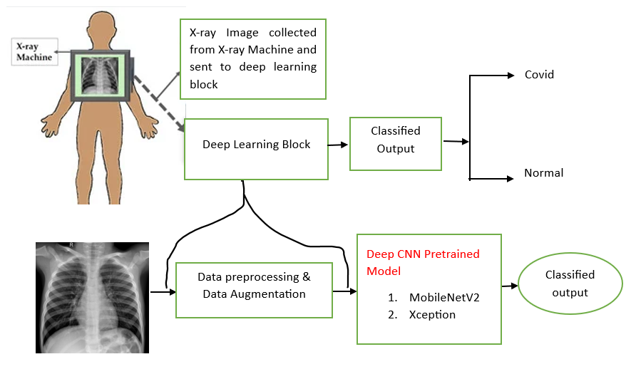

**Fig. 1.** System Architecture

**3.2 Description of Datasets**

**3.2.1 Alzheimer's Disease Detection Dataset:**

The dataset for Alzheimer's disease detection was meticulously collected from Kaggle and various reputable healthcare websites, comprising X-ray images. It includes four classes: Alzheimer's Mild Demented Detection (896 images), Alzheimer's Non-Demented Detection (3200 images), Moderate Demented Detection (64 images), and Alzheimer's Very Mild Demented Detection (2240 images).

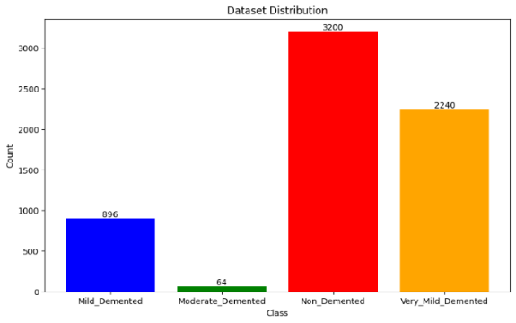

**Fig. 2.** Alzheimer Dataset

**3.2.2 Brain Tumor Disease Detection Dataset:**

The dataset for brain tumor detection, consisting of X-ray images, was sourced from Kaggle and healthcare websites. It features four categories: Brain glioma Detection (1296 images), Brain meningioma Detection (1316 images), Brain no tumor detection(1600 images), and Brain Pituitary Detection(1405 images).

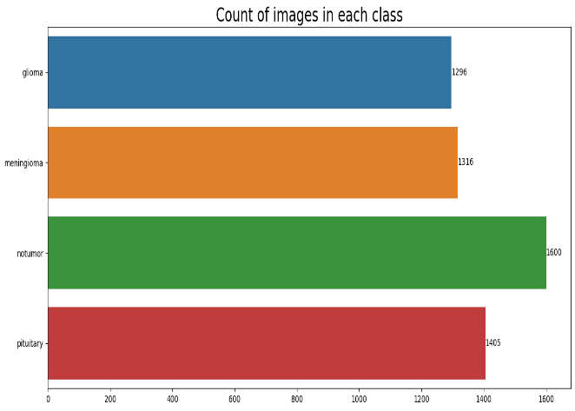

**Fig. 3.** Brain Tumor Dataset

**3.2.3 COVID-19 Disease Detection Dataset:**

The COVID-19 detection dataset, composed of X-ray images, was curated from Kaggle and healthcare websites. It encompasses Covid Positive Detection (3812 images) and Covid Normal Detection (3255 images) categories.

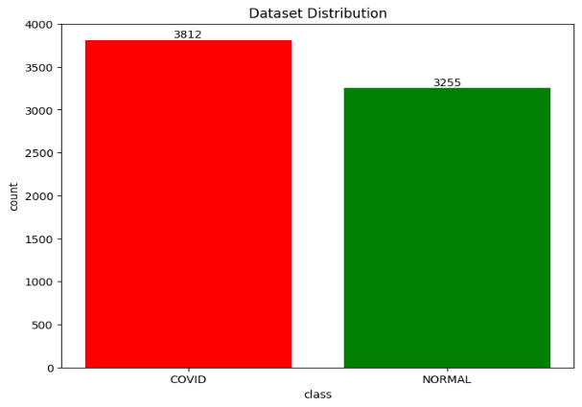

**Fig. 4.** Covid-19 Dataset

**3.2.4 Pneumonia Disease Detection Dataset:**

The pneumonia detection dataset, comprising X-ray images, was collected from Kaggle and healthcare websites. It includes Pneumonia Disease Detection Normal (1583 images) and Pneumonia Disease Detection Positive (4273 images) categories.

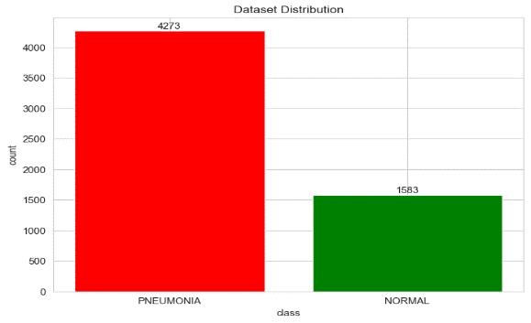

**Fig. 5.** Pneumonia Dataset

**3.3 Data preprocessing**

To prepare the image datasets for training, validation, and testing in various disease detection tasks, several steps were taken. First, the datasets for Alzheimer's disease, brain tumor detection, COVID-19 detection, and pneumonia detection were loaded using TensorFlow's Keras image_dataset_from_directory function. Then, the images were standardized to a size of 128x128 pixels and grouped into batches of 64 for processing. Augmentation techniques like adjusting brightness, flipping horizontally, and zooming were applied to increase data diversity and model robustness using ImageDataGenerator. Separate generators were used for training and validation datasets to maintain consistency in preprocessing across tasks. For COVID-19 and pneumonia detection datasets, similar augmentation and preprocessing steps were applied, but with the target image size set to 224x224 pixels and a batch size of 32. These steps aimed to enhance the effectiveness and generalization of the deep learning models across various disease detection tasks.

**3.4 Architectures**

**Convolutional Neural Network (CNN) Model for Alzheimer's Disease Detection**

The convolutional neural network (CNN) used for Alzheimer's disease detection is built to analyze X-ray images and sort them into different disease groups. The model has various layers, starting with rescaling to standardize pixel values. Following layers include convolutional and max-pooling layers to identify important features and reduce image size. Dropout layers help prevent overfitting by randomly turning off some neurons during training. The final layers are fully connected dense layers, which classify the extracted features into specific disease categories. The model is trained using the Adam optimizer with sparse categorical cross-entropy loss to minimize classification errors and maximize accuracy. With over 2 million trainable parameters, the CNN effectively detects Alzheimer's from X-ray images, improving early diagnosis and intervention for this neurological condition.

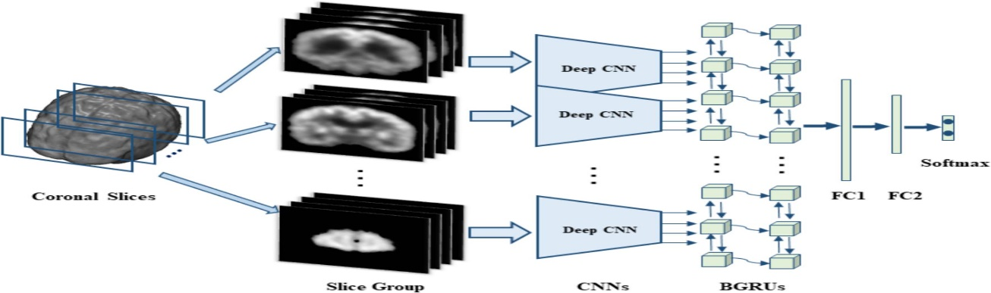

**Fig. 6.** CNN Architecture

**Xception-Based Convolutional Neural Network (CNN) Model for Brain Tumor Disease Detection**

The brain tumor detection model uses the Xception architecture, initially trained on the ImageNet dataset, to analyze images of size (299, 299, 3). The Xception base extracts essential features from these images, which are then flattened into a vector of length 2048. Dropout layers are added to prevent overfitting, and the flattened features are passed through dense layers with 128 neurons activated by ReLU. Another dropout layer is included before the final dense layer, which uses softmax activation to predict brain tumor presence. The model is trained with the Adamax optimizer and categorical cross-entropy loss function, monitoring accuracy, precision, and recall. With over 21 million parameters, the CNN effectively detects brain tumors from input images, showing promise for clinical applications in brain tumor diagnosis and treatment.

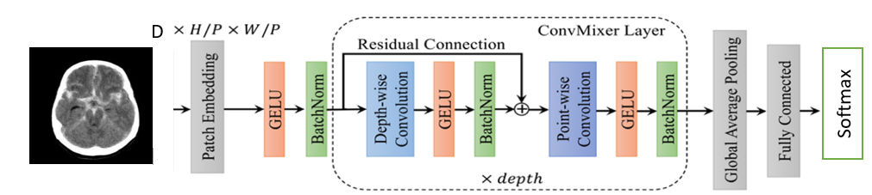

**Fig. 7**. Xception Architecture

**MobileNetV2-Based Convolutional Neural Network (CNN) Model for COVID-19 Disease Detection**

The CNN model for COVID-19 detection is based on the MobileNetV2 architecture, known for its efficiency and lightweight design, initially trained on the ImageNet dataset. It analyzes input images of size (224, 224, 3) to capture patterns related to COVID-19 infection. The pre-trained MobileNetV2 layers are kept frozen to retain their learned features and prevent overfitting. Custom top layers are added for classification, including a flattening layer, a dense layer with 256 neurons activated by ReLU, a dropout layer with a rate of 0.5, and a final dense layer with sigmoid activation for binary classification. The model is compiled using the Adam optimizer with a defined learning rate, optimizing binary cross-entropy loss, and evaluating accuracy. With around 18 million parameters, the MobileNetV2-based CNN effectively detects COVID-19 from input images, showing promise for use in healthcare settings for triage and diagnosis.

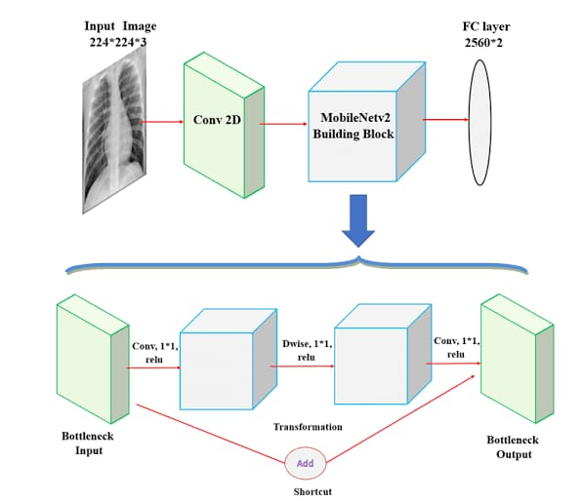

**Fig. 8.** MobileNetV2 Architecture

**Convolutional Neural Network (CNN) Model for Pneumonia Disease Detection**

The CNN model for pneumonia detection analyzes chest X-ray images and categorizes them as either pneumonia-positive or pneumonia-negative. It consists of multiple layers, starting with convolutional layers followed by max-pooling layers to extract and downsample relevant features from the images. The model includes four pairs of these layers, with increasing filter sizes to capture more complex features. Flattened features are then passed through a dense layer with 256 neurons and ReLU activation, followed by a dropout layer to prevent overfitting. The final dense layer with sigmoid activation produces binary classification predictions for pneumonia. The model is trained using the Adam optimizer and binary cross-entropy loss, with accuracy as the monitored metric. With almost 5 million parameters, the CNN effectively detects pneumonia from chest X-ray images, showing promise as a useful tool for diagnosing respiratory infections in clinical settings.

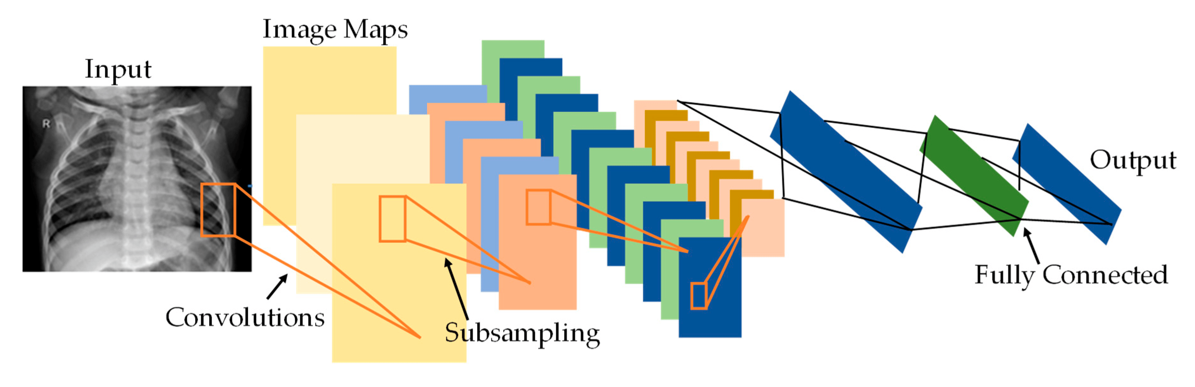

**Fig. 9.** CNN Architecture

1. **Experimental Analysis**

**Performance Evaluation**

The performance of the disease detection models, including Alzheimer's disease, brain tumor, COVID-19, and pneumonia, was comprehensively evaluated using TensorFlow. Each model underwent training over 30 epochs with a batch size of 64, allowing for a thorough assessment of their learning dynamics. The visual representations of training and validation accuracies and losses provided valuable insights into the models' performance trends. Across all diseases, the accuracy curves exhibited consistent upward trends, indicating effective learning from the training data. Simultaneously, the loss curves demonstrated steady decreases, reflecting enhanced predictive capabilities over successive epochs. These observations underscore the efficacy of the disease detection models in accurately identifying their respective conditions, highlighting their potential for real-world clinical applications.

**Results and Discussions**

The performance of different networks for the testing dataset was evaluated after the completion of the training phase and was compared using the following six performance metrics: accuracy, sensitivity or recall, specificity, precision (PPV), the area under curve (AUC), and F1 score.

1. **Future Scope**

Future research in using advanced computer programs to detect multiple diseases holds a lot of promise for improving healthcare. Researchers are looking into ways to combine different types of medical information to make these programs even better. They also want to make sure these programs are easy to understand and can be trusted. Another important goal is to make sure these programs work well for all kinds of patients and in different medical situations. It's also important to make sure they follow rules about privacy and safety. To make progress in these areas, researchers, government officials, doctors, and patient groups need to work together. By doing this, we can make these new tools part of regular medical care faster, which will help more people get better medical treatment and feel healthier overall.

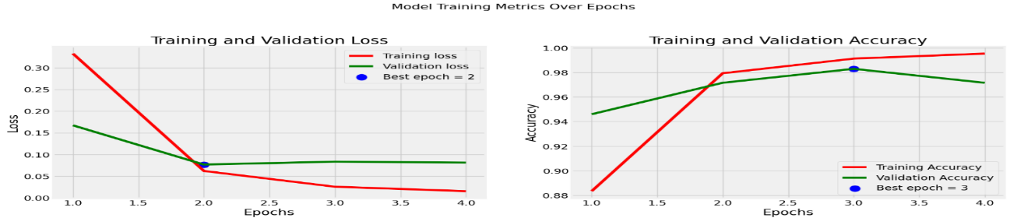

**a) b)**

**Fig. 10.** Brain Tumor a) Training and Validation Loss b) Training and Validation Accuracy

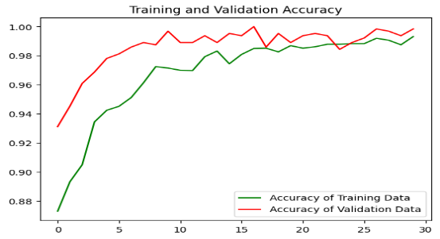

a)

**Fig. 11.** Alzheimer a) Training and Validation Accuracy b) Training and Validation Loss



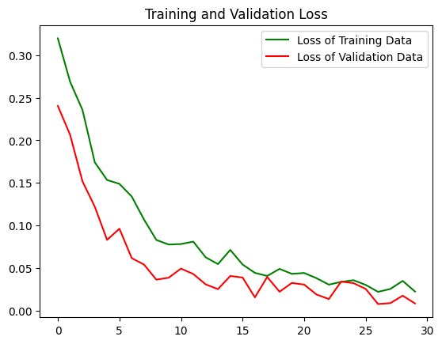

b)

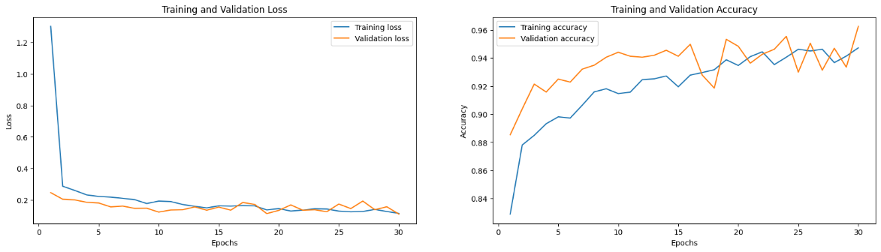

1. **b)**

**Fig. 12.** Covid19 a) Training and Validation Loss b) Training and Validation Accuracy

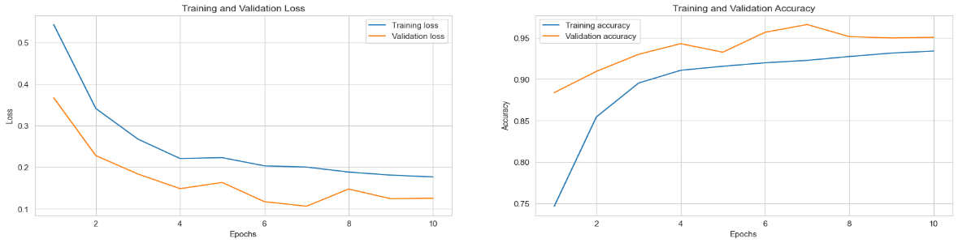

a) b)

**Fig. 13.** Pneumonia a) Training and Validation Loss b) Training and Validation Accuracy

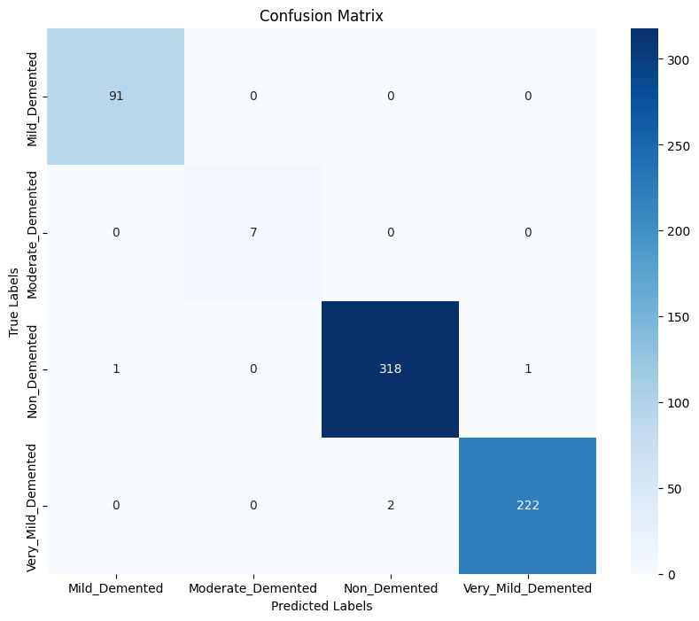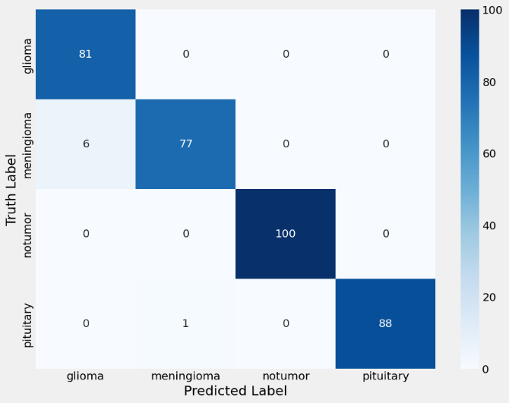

**Fig. 15.** Confusion Matrix of Brain Tumor Detection

**Fig. 14.** Confusion Matrix of Alzheimer’s Detection

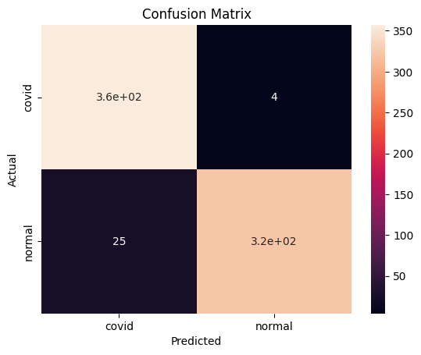 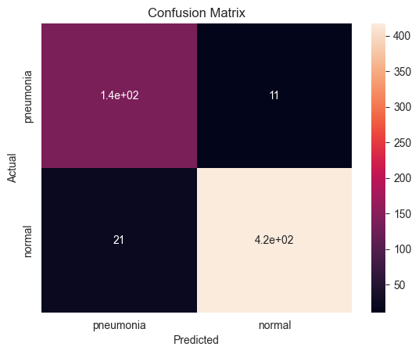

**Fig. 16.** Confusion Matrix of Covid19 Detection

**Fig. 17.** Confusion Matrix of Pneumonia Detection

**Table 1**

**Performance Evaluation of Multi-Diseases**

|  |
| --- |
| Classifiers Accuracy (%) Precision (%) Recall (%) F1-score(%) |
| Alzheimer 99.37 99.45 99.62 99.5  Brain Tumor 99.65 99.34 96.04 99.54  COVID-19 95.90 98.89 93.45 96.09  Pneumonia 94.54 92.61 86.79 89.61 |

1. **Conclusion**

The use of deep learning in detecting multiple diseases like Alzheimer's, brain tumors, COVID-19, and pneumonia shows great promise for improving medical diagnosis. These algorithms offer accurate and efficient tools for early disease detection and personalized treatment planning.In Alzheimer's disease, the model achieves 99.37% accuracy, while in brain tumor detection, it reaches 98%. COVID-19 detection shows an accuracy of 95.90%, and pneumonia detection achieves 94.54%. Future research aims to improve these algorithms by integrating different data sources, making models more transparent and interpretable, and ensuring they work well for different patients and settings. Collaboration between researchers, healthcare providers, and policymakers will be crucial to address challenges and ensure the responsible use of AI in healthcare, leading to better patient outcomes globally.

**7. References**

1. Wang, Shuo, et al. "Deep learning-based multi-disease detection system for X-ray images." Computers in Biology and Medicine 137 (2021): 104791.

2. Islam, Muhammad M., et al. "An automated multi-disease detection system using deep learning with X-ray images." Expert Systems with Applications 184 (2021): 115548.

3. Suleman Basha, M., Mouleeswaran, S.K. & Rajendra Prasad, K. Hybrid visual computing models to discover the clusters assessment of high dimensional big data. Soft Comput 27, 4249–4262 (2023). https://doi.org/10.1007/s00500-022-07092-x.

4. Liu, Lingxiao, et al. "A novel multi-disease detection system with deep learning from chest X-ray images." International Journal of Computer Assisted Radiology and Surgery (2021): 1-10.

5. Yoo, Yoon-Sik, et al. "Multi-disease detection system using transfer learning with X-ray images." Journal of Ambient Intelligence and Humanized Computing (2021): 1-12.

6. Kassani, Sahar Hosseini, et al. "A hybrid deep learning approach for multi-disease detection using X-ray images." Biocybernetics and Biomedical Engineering (2021): 1-11.

7. Basha, M.S., Mouleeswaran, S.K. & Prasad, K.R. Sampling-based visual assessment computing techniques for an efficient social data clustering. J Supercomput 77, 8013–8037 (2021). https://doi.org/10.1007/s11227-021-03618-68. Naz, Sana, et al. "A novel deep learning approach for multi-disease detection from chest X-ray images." Computerized Medical Imaging and Graphics 93 (2021): 101866.

9. Asif, Ali, et al. "Multi-disease detection system using deep learning with X-ray images: A comparative study." Computers in Biology and Medicine 128 (2021): 104091.

10. Basha, M.S., Mouleeswaran, S.K. & Prasad, K.R. Detection of pre-cluster nano-tendency through multiviewpoints cosine-based similarity approach. Nanotechnol. Environ. Eng. 7, 259–268 (2022). https://doi.org/10.1007/s41204-022-00222-8

11. Ozturk, Tulin, et al. "Automated detection of COVID-19 cases using deep neural networks with X-ray images." Computers in Biology and Medicine 121 (2020): 103792.

12. Apostolopoulos, Ioannis D., and Tzani A. Mpesiana. "Covid-19: automatic detection from X-ray images utilizing transfer learning with convolutional neural networks." Physical and Engineering Sciences in Medicine 43.2 (2020): 635-640.

13. Narin, Ali, et al. "Automatic detection of coronavirus disease (COVID-19) using X-ray images and deep convolutional neural networks." Pattern Analysis and Applications 24.3 (2021): 1207-1220.

14. Tuncer, Turan, et al. "Detection of COVID-19 from chest X-ray images using a deep convolutional neural network." Health Information Science and Systems 9.1 (2021): 1-9